How to setup load balance at H721
First you need install 2 modems at M.2 and Mini-picie slot and sim cards, sample use RM502Q-AE and EP06
Normally Mini-pcie modem will power up first and M.2 modem will power up secondly . So system will create Modem subsystem In sequence. That is to say, CDC-wdm0 & ttyUSB0 ttyUSB1 ttyUSB2 is Mini-pcie modem, CDC-wdm1 & ttyUSB3 ttyUSB4 ttyUSB5 is M.2 modem.

- Delete all usbwan* at Network-interface
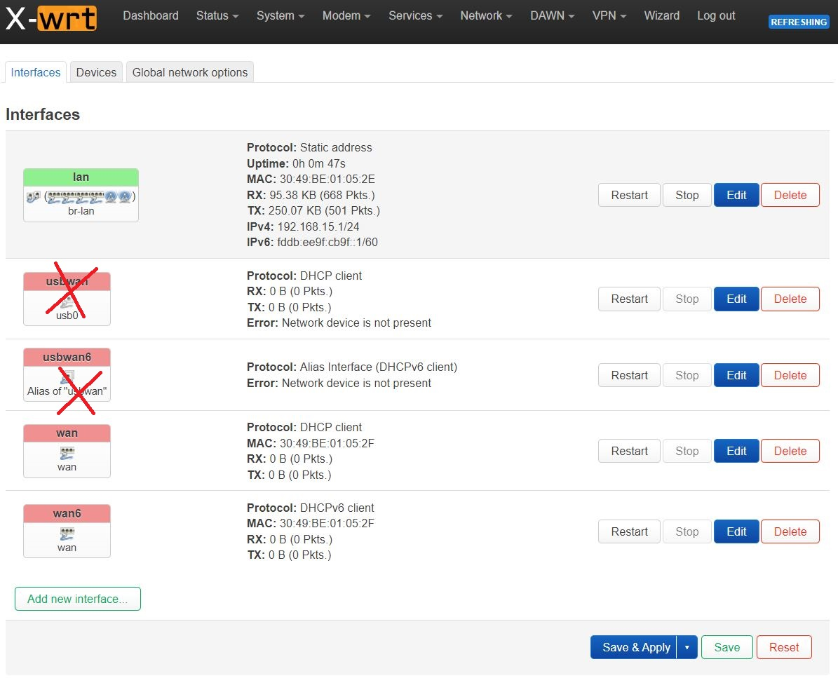
save & apply

- Open network-Xwan， check enable xwan, set 3 at Number of xwan, check Auto balanced setup , set ip 8.8.8.8 at Tracking hostname or IP address IPv4 and IPv6 at Internet Protocol
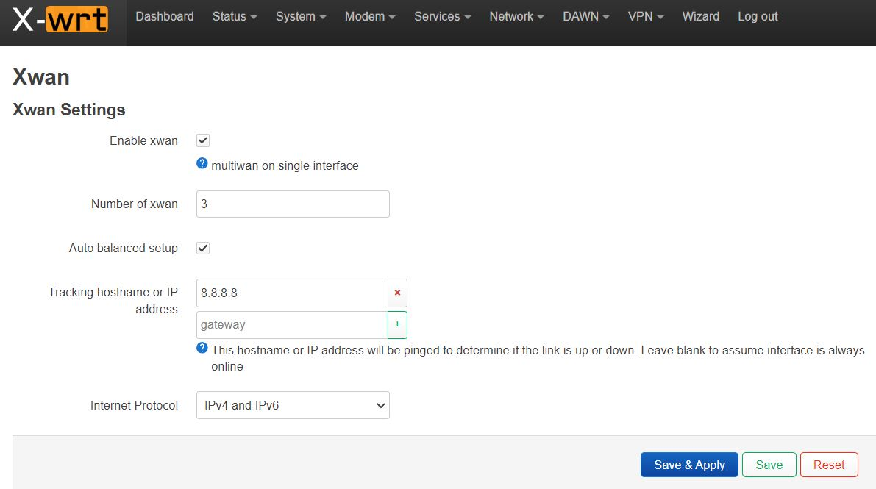
save &apply

- Wait for 30 second, network-interface change xwan01 general settings Protocol QMAP Cellular switch protocol Modem device /dev/cdc-wdm1 (M.2 modem) input your apn and related info. Advance settings. Set Use gateway metric 801 . Firewall settings.
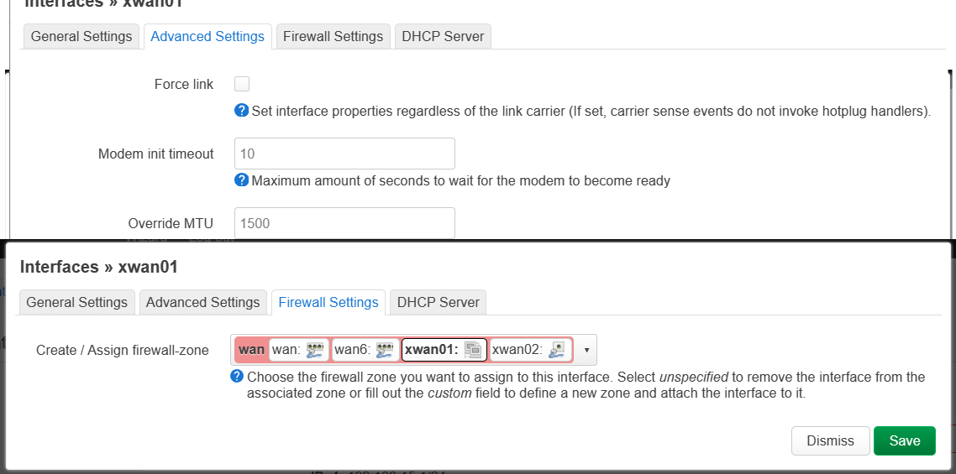
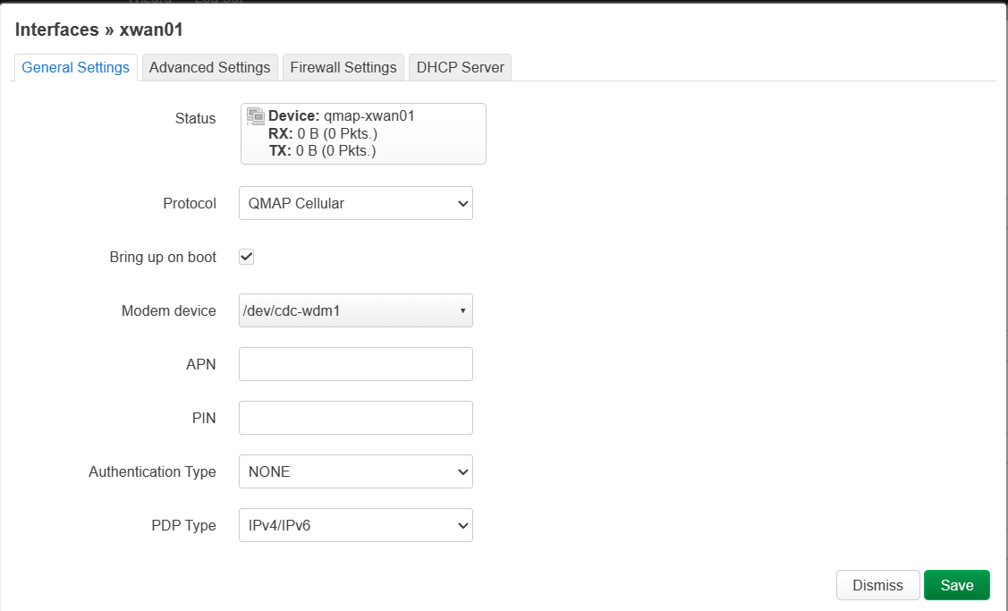

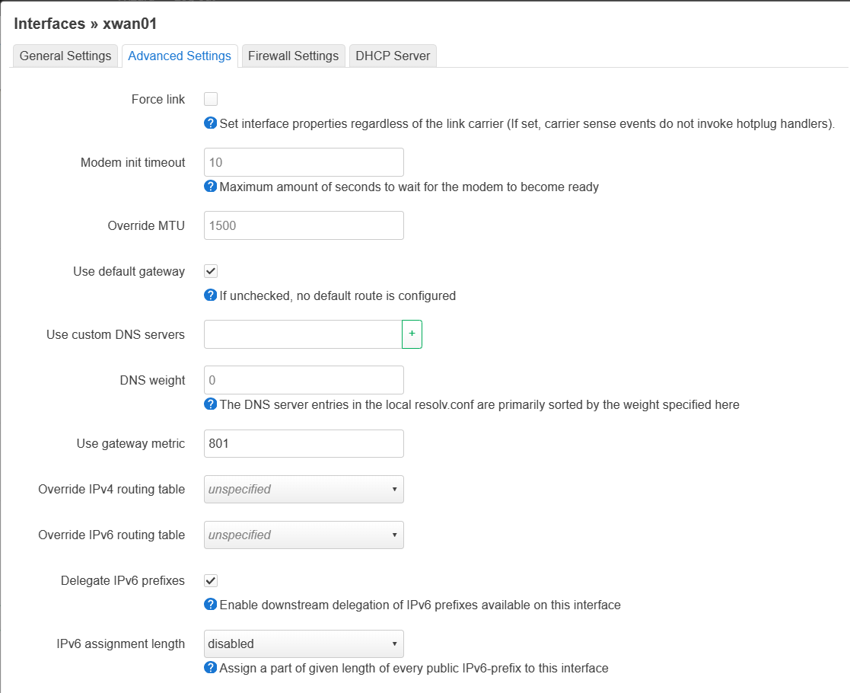
Setup xwan02. pay attention, modem device /dev/cdc-wdm0(Mini-pcie modem) and metric use 802
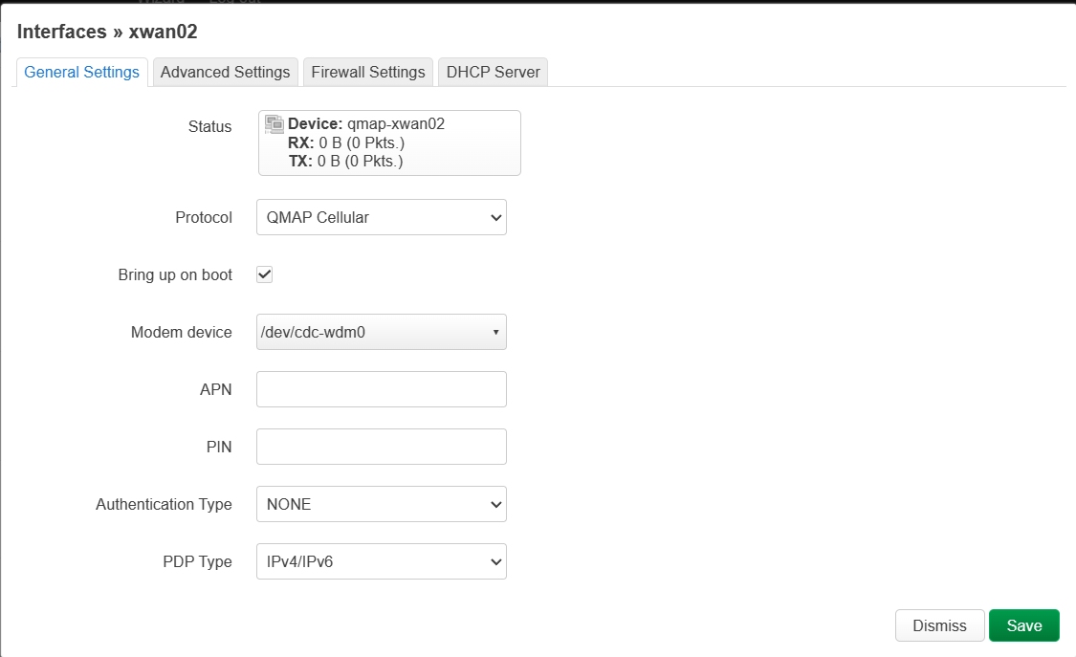
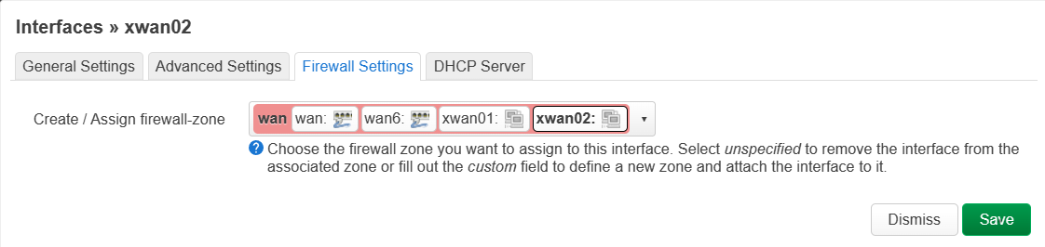
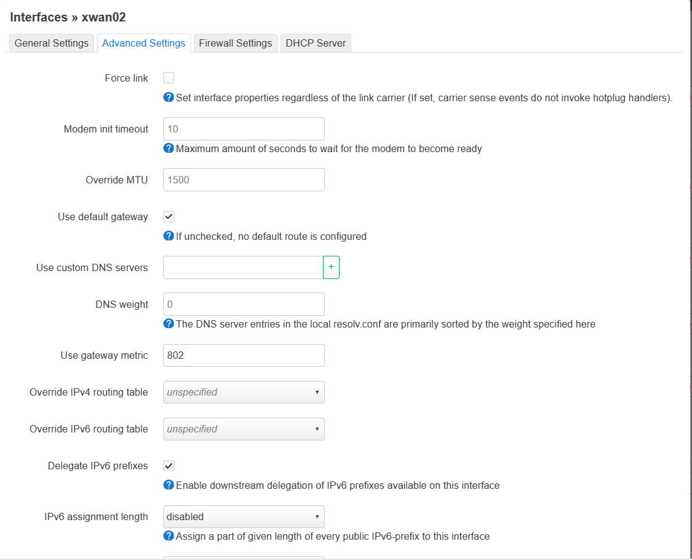
Save and applyadmin

- After you finish settings, you can check the Mwan status at status-MultiWAN Manager

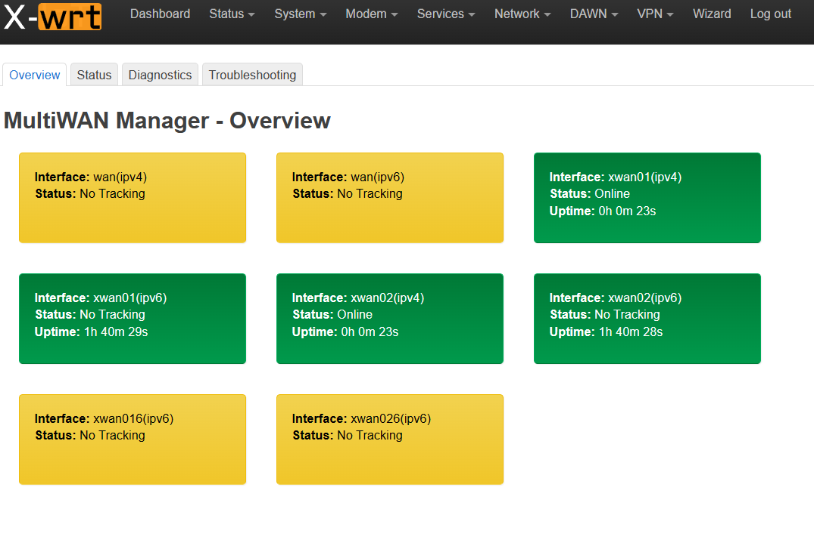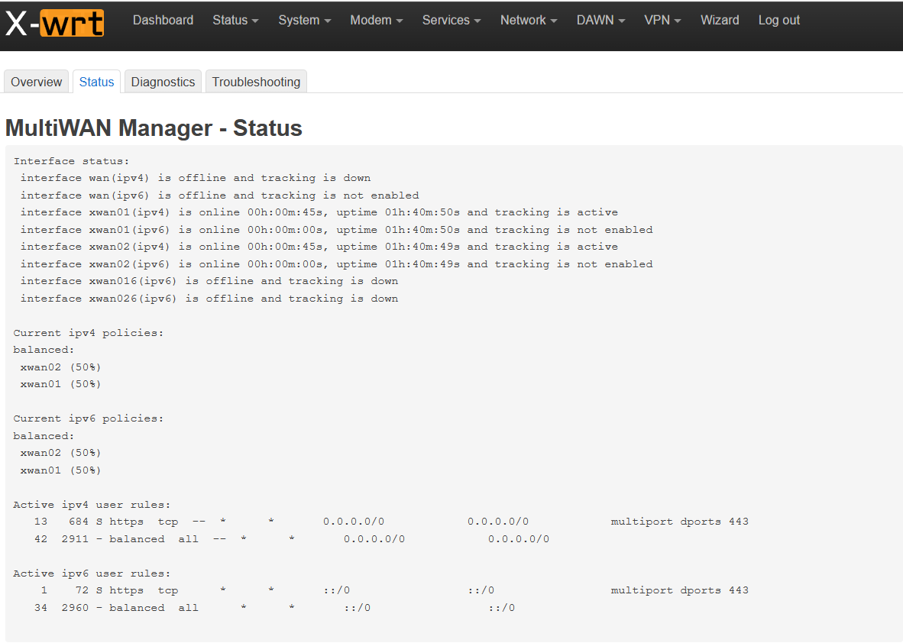
- You can also set more at network-MultiWan Manager, such as Wan priority at Member Metric
.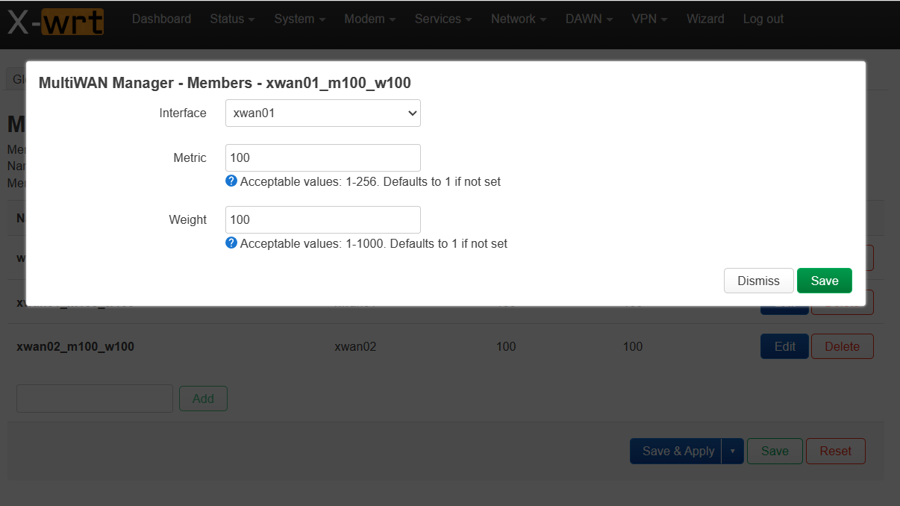

.

Czech language instructions :
1. síť, rozhraní, odstranit všechna rozhraní usbwan** uložit a použít nastavení
2. síť, multi-dial, zapnout multi-dial, 3-dial sledování hostitele zachovat bránu, ostatní odstranit, protokol vybrat ipv4 a ipv6 uložit a použít nastavení
3. počkejte 30 sekund, zadejte síť, rozhraní, upravte xwan01, vyberte protokol QMAP, nakonfigurujte první modul, bránu skokového bodu 801
4. zadejte síť, rozhraní, upravte xwan02, zvolte protokol QMAP, nakonfigurujte druhý modul, brána počet skoků 802.
Nakonec nastavení uložte.

